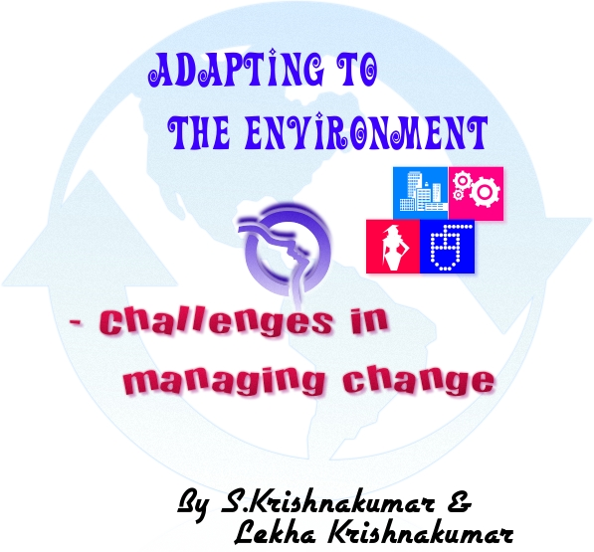

©2008 Lekrish Consultants Pvt. Ltd. retains all copyright and other intellectual property rights for the contents of this book. Unauthorized copying, public performance and broadcasting of this content are prohibited and punishable under law.

About the Book

Purpose

In today’s dynamic environment, managing change is the most challenging task. Business managers have to demonstrate adaptability to change. It is said, “It is not the Strongest or the Bravest, but those who are most adaptable to change, that survive in the long-run”. To sustain and grow in the present competitive environment, organizations have to innovate, implement robust processes and controls, and show flexibility and quick response to change. The very act of bringing improvement in the working environment, involves change in attitude.

Approach

This book tries to analyze the key ingredients to change or adapt to change through lucid enumeration of real life instances and case study and addresses questions like:
- What Change?
- Why should I change?
- What should I change?
- When should I change?
- How do I adapt to change?
- How do I make others change?

About the authors
S.Krishnakumar is an Associate member of the Institute of Chartered Accountants of India which is the premier institution governing the profession of accountancy in India. His total industry experience spans over 15 years which includes extensive financial and management audit experience. He has served as finance controller and business support manager with leading Fortune 500 companies for over 9 years; He has good insights and understanding of international taxation, business development initiatives, strategic planning and human resource management.
Lekha Krishnakumar is a Fellow member of the Institute of Chartered Accountants of India. Her total industry experience spans over 15 years which includes, over 11 years of experience in financial and management audits, company formation, statutory compliance and taxation. She has served as Commercial manager in MNCs responsible for financial planning, project control and customer interface. She has an excellent academic record with state level accolades in economics and accounts, and merit in the foundation course of Institute of Chartered Accountants of India; currently, she has conducted workshops on accounting and management word-wide and gives regular presentations at the Southern India Regional council of the ICAI.

Contents
About the Book 3
About the authors 4
Chapter 1 - Introduction 6
Chapter 2 – Where does change take place? 10
Chapter 3 – Our Environment 12
Chapter 4 – Change? What Change? 15
Chapter 5 - Why should I change? 16
Chapter 6 – What should I change? 22
Chapter 7 – When should I change? 38
Chapter 8 – How do I adapt to change? 40
Chapter 9 – How do I make others change? 49
Chapter 10 – Conclusion 52
Other titles by the same authors 57

Chapter 1 - Introduction

A great thinker Demosthenes said – “small opportunities are often the beginning of great enterprises”.
In the global market, increased competition brings about innovation thereby rendering current methodologies obsolete.
So in this kind of environment how do we compete and succeed?
Change is permanent, it is inevitable. We are not what our ancestors were, say, two thousand years back. In fact, we are not what our grandparents were some fifty years back. Most of the things have changed – lifestyle, clothes, value of money, type of jobs, education system, technology, some traditions etc.
So, whether we like it or not or whether we call it positive or negative, change is here to stay. Once, again, positive or negative change depends on the person’s perception. For example, today twenty-twenty cricket is played and liked by many of us. There are many of us who do not like this model at all. Whether we like it or not, this game is played and if you are an ardent cricket fan, you will be drawn into its ambit compulsively, you can’t help it!
Similarly, let us take music today and sixty years back. Purists would not like the kind of fusion music that is prevalent today and liked by many. They would call it a negative change, whereas there are some who would call it positive. There are many old traditions followed, probably in the beginning of the nineteenth century, which are losing ground because of advancement in thinking and technology. Some would call it “positive” change; some might call it “negative” change. So, “positive” or “negative” depends on a person’s preference, perspective and paradigms.
Similarly, whether fast or gradual, change happens everywhere.
Now, when we talk of change, what questions come to our mind? First of all we say,
- Change? What Change?
- Why should I change?
- What should I change?
- When should I change?
- How do I adapt to change?
- How do I make others change?

Our hand book will try to answer these questions. Once we know the answer to these questions, we would be adept in managing the issues posed by today’s challenging environment.
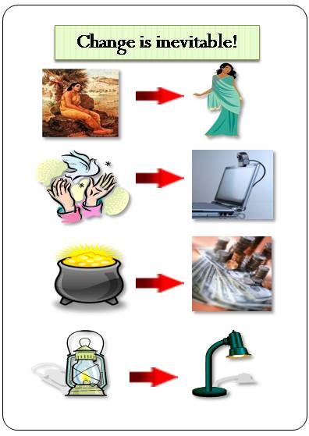
Let us see how we would react if…
- Legislation is passed that all private cars should be painted green irrespective of size, shape or design?
- In an organization Shorts and T-shirts are made acceptable dress codes?
- Just like Euro, “Asio” currency is introduced for all countries in Asia?
- Voting age is made 14 instead of 18?
- A new communication serum is invented which can be injected in your ears replacing phones forever?
These questions were posed to an audience in the age group of 30-60 when the authors were conducting a live workshop on this subject.
The responses to these questions were mixed. Some thoughts like “changing the voting age” met with vehement oppositions.
Our reaction to these kinds of questions would show the level of openness we show towards anything new and challenging that is put forth in front of us.

Chapter 2 – Where does change take place?
Change could be internal or it could be external.
When changes take place within ourselves, we call it internal change. And, when there are changes in the environment around us, we call it external change.
Sudden or gradual drastic changes in our thinking, attitude, paradigms, ambitions, behavior, culture, religion etc., due to education, accidental occurrences, events like marriage, change of location etc., are internal changes.
These arise within an individual and affect the individual and people in his/her close proximity. These changes may have no direct bearing on the community as such unless and until that person is in a highly influential position like the Head of a State, or a religious leader or somebody in a highly influential position!
But, internal changes are necessary to adapt to the external change which is the environment. We will be discussing how we can bring about internal change to adapt to the environment.
Our hand book deals with “adapting to the environment”. Therefore, we would be discussing at length the external environmental changes which would have an impact on our day to day lives and how we can manage the challenges posed by those changes.
During our discussion, when we say internal change, this would mean within the individual. Anything else is external including work, business.

Chapter 3 – Our Environment

We must first analyze what our environment consists of.
Our environment can be broadly categorized as:
• Political
• Economic
• Technological
• Social & Cultural
• Work or Organizational
• Psychological
• Natural
Now, before you start wondering as to whether there is going to be a lecture on politics, or technology or natural calamities, let us clarify our point. We are affected by a small change in any of these environments. All these factors has influence on our thinking, way of living, the way we interact with our family, relatives, friends, colleagues and general public at large. You may say if there is turbulence in the economic environment, it has a direct bearing on our purses. How does it affect me if voting age is changed to fourteen?
But, every aspect of environment has a bearing in the economic environment. When 14 year olds start voting, the whole thinking may change. They may vote for a government which thinks radically differently. If the government changes and their thinking bring about change in tax regulations, will it not affect our purses?
If a huge earthquake rocks a place (where we don’t live), can we be immune to the losses suffered by people in that region? Doesn’t the economy and businesses get affected by it? The insurance and re-insurance businesses worldwide are going to be totally affected. This will definitely have a domino effect.
Let us take the technological environment. Today’s banking has totally changed. It is not what it used be even fifty years back. Internet banking and ATMs have totally changed the way banks function. Automation has brought about a change in the outlook and methodologies of audit and internal control system. What was relevant in manual system is no longer relevant or feasible in automated system.
Change in Management, policy changes, change in shareholding pattern of an organization affect the employees, auditors, and all other stake holders concerned with that organization.

Different and newer kinds of businesses are springing up daily due to various social and cultural changes. For example business of marriage contractor or a wedding planner is a flourishing business these days. Something like event management – DJs, RJs are fast growing and lucrative professions.
Psychological change is a shift in perception and thinking. For example, if a large number of people start believing that doing aerobics or going to the gym thrice in a week is good for the health, these businesses start thriving. Similarly, if mothers start feeling disposable diapers are better than cloth nappies for their children, these industries start happening. These are paradigm shifts which take place in a collective manner.
The degree of influence of any particular environmental change may vary depending on the situation. In today’s scenario, environment is fast changing. The earlier we adapt to it, the better it is for us in the long run.

Chapter 4 – Change? What Change?

When we talk of change, the first question that comes to our mind is What Change?
Identifying change or the shift from normal practice, which may affect us, is the first step.
The answer to this question would be internal change or external change which affects.
For example, if the Finance Minister introduces another charge or levy of tax, what do we do? First we read about, confer with our friends and professional colleagues, discuss and discuss and discuss in various forums, blogs and in e-mail groups till we are totally convinced that this is yet again a hindrance in our otherwise smooth professional life. And, finally, we reconcile to the idea that however we may dislike this new regulation, we have no choice but to accept it and take steps to implement the same.
Finding a difference, noting dissimilarity, deviating from an accepted practice – all these are elements of change.

Chapter 5 - Why should I change?

This is a typical question which most of us would ask. This is asked by people because there is a general resistance to change. Nobody would like to disturb the apple cart. People feel that if something has been working for them well for years or has worked perfectly well in the past, why should that be changed?
This was asked when computers were introduced, internet came into full force, sewing machines were introduced, machines replaced men in factories, railways came into full force, elevators were built, ERP brought in, Free trade bill introduced….and whenever a new thing was introduced.
Let us see how we can answer this question.
- Why should I change? -Because, it is mandatory.
Some changes have to be adopted because they have been imposed on us, like the tax regulation we discussed about. Whether we like those changes or not, we have to accept them. A new president getting elected, stock markets crashing, Tsunami or Tornado, are instances which are thrust on us and we have to adapt to these circumstances.

- Why should I change? -Because it is a positive change.
Some changes bring about improvement in the way we live, we think or we do things. For example, airplanes changed the way we travel; satellites, e-mails and internet brought about a revolution in communication; certain change in policies like flexi-timings, work from home bring relief to lot of people who have travel constraints. Abolition of certain social practices like child marriage and ‘sati’ (in India) has been positive revolutions.
There have been lots of changes which have made the civilization as it is today. Improved infrastructure, education, health-care are a boon to the present civilization. Globalization has literally shrunk the world. Any positive change is always welcome!
- Why should I change? -Because it is a welcome change.
You have been waiting for this change to happen. It has come as breather - a wave of fresh air! There are certain events which bring about a change in the regular or the usual. Not necessarily it brings an improvement, but it breaks the monotony. For instance, introduction of business casuals, colorful dress codes, fusion music, variety of products, colorful presentations, multi-colored theme painting of the house.
- Why should I change? -Because I have to compete and grow.
Pepsi introduces “Mirinda”, Coke has to come up with something tangy – “Fanta”. Once upon a time only net and coils were there to protect against mosquitoes. Goodnight company came up with mosquito repellents. Then many of them caught up. There is competition everywhere. If I don’t adapt myself to the changing environment, I will not be able to cope up with my competitors.
- Why should I change? -Because I have to survive in the long run.
There are certain technologies which may not impact businesses immediately, but in the long run, it would be better to adopt them to survive. Certain management concepts like, Six-Sigma will be useful in the long run. Adopting a very systematic organizational process will go a long way and shall come handy when the business growth is sudden and phenomenal.
Let us give an example; a former acquaintance was a consultant for hotel management. He had a lean-mean staff and was controlling the whole organization. He had simple accounting package, which was fine for a small organization. A few years back, he decided to build a few hotels himself taking the help of external funding and suddenly his organization grew multi-folds. The accounting package could not take the load; he did not create layers of management and tried to keep control of everything. He just was not willing to change his management style and eventually, his venture just did not take off.
- Why should I change? -Because, if I don’t change today, I will have to eventually.
There are no more audio or video cassettes today and very less black and white Television sets. Radios-Transistors-Tape recorders-Where are they? There is a writer. He has beautiful hand writing. He has always enjoyed writing with an ink-pen – the fountain pen. Today, this is a very scarce commodity. The pen which needs to be filled in with filler is hardly available. So, reluctantly, many a times he has to use the gel pen or the ink-pen with the tube filler!
Because of certain technological improvements, certain gadgets go out of use and are not produced after new ones are introduced. Therefore, if we do not plan to change today, we will have to change anyway, eventually!
- Why should I change? -Don’t Change!
There are certain things which need not be changed at all! Just because a neighbor or friend is doing something, I need not do it.
For example, suppose, my neighbor changes his car model every two years, I need not follow it. If some people have stopped believing in the institution of marriage, I need not alter my beliefs. I still believe in marriages and would not adopt live-in-relationship models. Somebody says a particular dress is totally out of fashion for example saris in India, I need not follow their thinking and stop wearing saris.
Certain changes need not be adopted just because they are trendy or fashionable. Let us take another example. Pears soap has been like this for over a century. It is good and many people love it the way it is. Just because newer soaps are coming in the market, this particular brand need not be changed. It could remain the same. Well, to increase market share, some more fragrances can be introduced. In the USA when new coke was introduced, there was such a big hue and cry that they had to go back to the old flavor. They called it mother coke!
Some changes are temporary or would continue to co-exist, and so it is not necessary to adopt them if we do not wish to!
So, identifying what has to be changed becomes very critical in deciding whether at all we need to change or not.
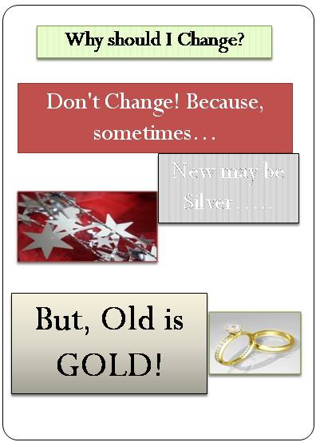

Chapter 6 – What should I change?

First we identified that there is a change in the environment. Second, we analyzed why we should do something for that. Like we discussed in the earlier section, certain things need not be changed at all! If we decided nothing needs to be done for that, we are through! No challenge is facing us! But, if we have decided that we have to do something about it, we have to see what that something is. This is the most critical aspect in managing change.
To bring about any change externally, first and foremost thing is change in attitude!
Talking about attitudes, there is a beautiful presentation on this which we received from a friend. The source is not known, but it would be appropriate if we go through that now.
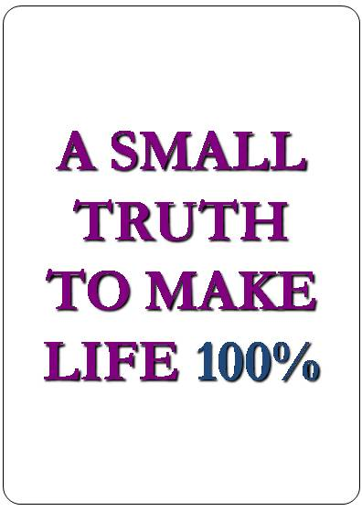
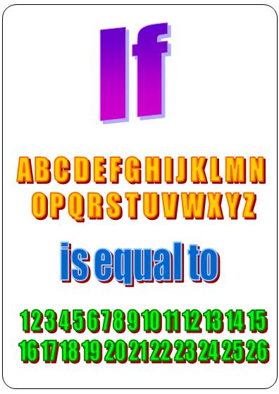
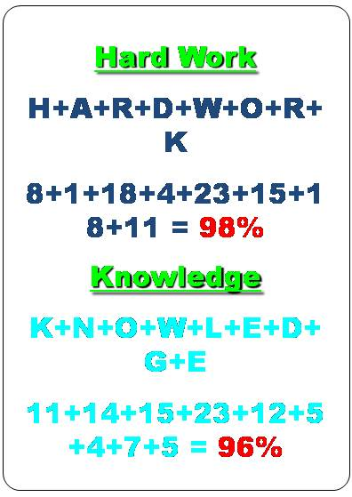
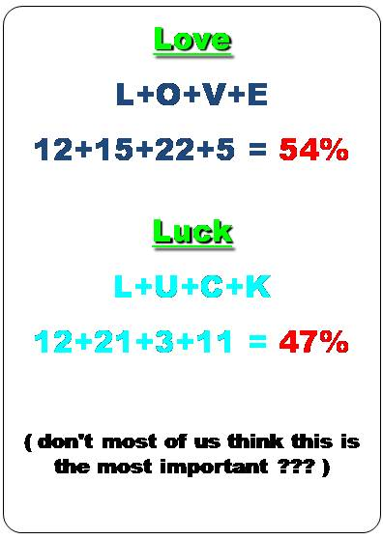
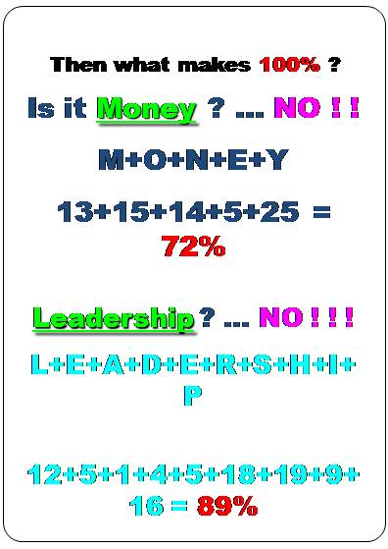
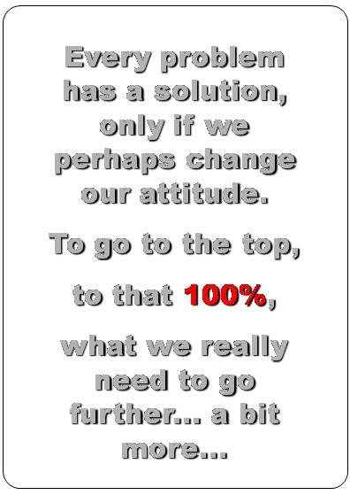
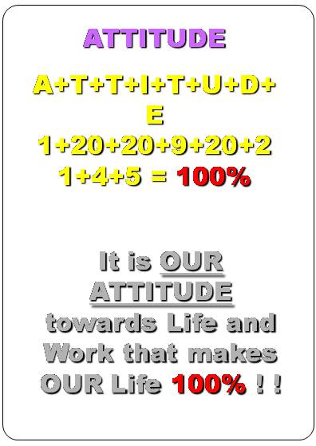
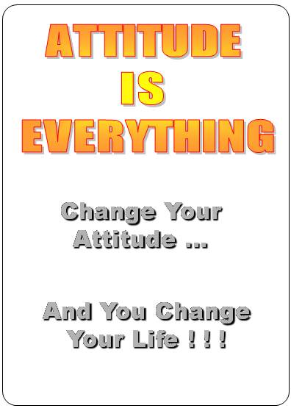
A “positive” attitude can do wonders while adapting to change.
Once we have made an internal change, we come to the external part. This may involve changing the way we live, spend, work or the place we live in, the people who work for us or our style of work, the products or services we offer or the methodologies we adopt. It could be anything.
Let us now take a case study and see how we work this out.
ST Ltd. manufactures garments for sale in the domestic and export markets. Shantha is the CEO of ST Ltd. (Shantha is a purely fictitious character and does not have any resemblance or bearing to any person living or dead!)
She has found a sudden dip in the profitability of her company. In fact, bottom line has gone into the red, whereas the company was making good profits till the previous year. Her Strategic Advisor has listed out the possible causes for this change in profitability. Now she has to analyze these causes and take a decision to change certain things so that the business is brought back on track.
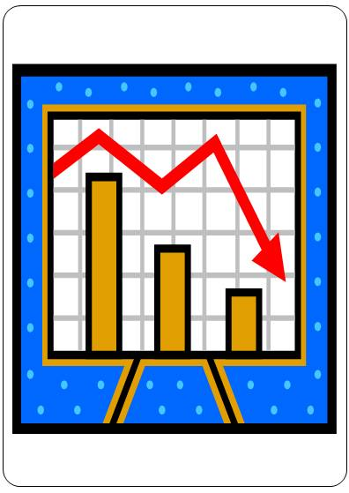

Possible causes:
1. Political:
- There is change in the Government. As a result policies have changed.
- The new government is conservative. It has levied 10% export duty on garment exports.
- But, has reduced Excise duty on garment manufacture.
- This has a mixed impact on profitability. Increase in Export Duty will increase cost for export sales whereas decrease in Excise duty will overall bring down cost of production. Let us say, the overall impact is 2% on the business.
2. Economic:
- There is general recessionary trend in the economy.
- Working capital loan getting delayed due to slower processing of loans by the banks.
- Managing cash flows is becoming costlier due to increased rate of borrowing and bill discounting.
3. Technological:
- Machines have become old. Newer faster skillful machines are available in the market.
- ERP is not being used. Real time monitoring of stocks cannot be done due to outdated technology. This has resulted in delay in ordering and production levels.
4. Social & Cultural:
- Dressing trends are changing fast.
- Trendier clothes are preferred in the market than traditional ones.
5. Psychological:
- Emphasis on casual clothing than formal clothing as there is a collective psychological change in the work environment.
6. Natural:
- Cotton production has gone down due to rains. Availability of raw material has come down which is impacting production.
- Work or Organizational:
Organizational causes are many. These are internal to the organization. The other factors are mainly external to the organization.
Sr. No | Weakness | Consequence
1 | The quality of identifying and qualifying prospects needed improvements | Excessive time, effort and money was being spent without any concrete results
2 | Over stocking at slack seasons | Cost of stocking has increased
3 | The business unit was overstaffed. | Increased overheads
4 | Cost control was not being implemented in a focused manner | Concentration on less material items leading to overall frustration and dissatisfaction
5 | Cash flows were not being effectively managed | Liquidity crisis on a regular basis
6 | Timely MIS was not presented to the management | No exception reports for the management to act on
7 | Poor debt collection system | Liquidity crisis, increased cost of capital employed, cost of dispute management
8 | Delay in order registrations and implementations | Slippages in deadlines, credibility loss, increased cost of implementation
9 | Pricing was heavily buffered | Shows poor costing methodologies, becoming uncompetitive
10 | High employee turnover | Loss in productivity

Shantha has to address not one but multiple problems. Any manager would be faced with many issues at the same time. She has to make a decision as to what changes she has to bring about in her organization to mitigate the losses caused by these factors and make the organization profitable.
This is her decision:
1. She cannot do anything about the tax implication, so she decides to absorb the cost.
2. Again, she cannot do anything about the interest rates. She can try and negotiate with Banks for lower rates or convert existing borrowings into a different type of borrowings which may be beneficial in the long run.
3. Pull out some investments which are not doing well and invest them in business instead of borrowing from Bank.
4. Make do with old machinery for one more year as there is general cash crunch. But, decides to invest in ERP for better automation and real time processing.
5. Increase production of trendier wear. Increase sales reach of traditional wear into other smaller cities as the current trend change is only in big Metros.
6. Reduce production of formals.
7. Change some pure cotton garments to cots wool or silk cotton or Jute depending on the type.
8. Strengthen internal processes and controls, improve HR policies, prune the organization size and increase competence of resources.
By making these decisions, she has addressed almost all her problems. How will she accomplish this? We will see that in another section.

Chapter 7 – When should I change?

The next step in change management is timing issue.
In the present era of globalization we need to find quick and reliable solutions to our quests. Business opportunities present themselves for a short while. Those who can quickly grasp and make optimal use of the given opportunities, ensure growth and success.
We could spell out some tips for making some timely adjustments:
1. Be Pro-active
2. React quickly to situations – do not procrastinate.
3. Take decisions but do not make hasty decisions (Like closing down a unit may not be the right approach).
4. Adopting consultative rather than autocratic management techniques may help. Team work may also be best suited.
5. Draw-up an implementation schedule to ensure adherence to plans properly. This is to avoid timeless behavior and attitude of people.



Chapter 8 – How do I adapt to change?

We have answered almost all the initial questions and decided we need to change something within a particular time span. Now we are going to see how we are going to bring about this change.
It may seem tougher to change one’s attitude but, it is much more trying to make others around us accept a change. This is the most challenging aspect of change management.
There are actually five components in this change management.
1. Vision
2. Skills
3. Incentive
4. Resources
5. Action Plan
Only if all these five components are mixed correctly, can we bring about any change. If any one of these components is mixing, adapting to change will not be smooth.
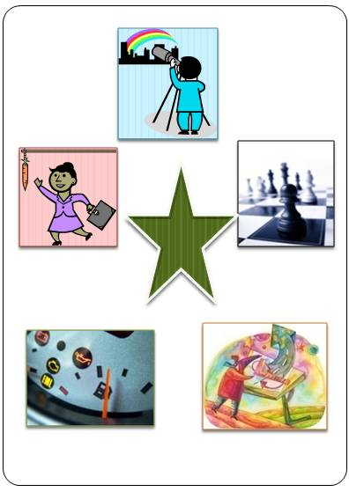
We will now see in detail what these terms mean individually.
- Vision:
The term vision has a very wide meaning and at times it is very vague. In common parlance vision is understood as seeing the future. The term is also used to describe things few people perceive while others don’t. It is an art of conceptualizing from the abstract. Vision is futuristic. Majority of human beings have a vision, a dream or desire. But, there is a fine line that separates a fantasy from a realistic vision. There should be clarity and conviction with respect to visions. The vision should be realistic and achievable.
Having said that let us take the example of our case study done earlier. Shantha, first has to define her vision before she even embarks into bringing about any changes in her organization. Let us say her vision 2020 is to expand and diversify to leather goods and plastic toys. But, what is her short-term vision? It is to turn around the business into a profit making one. She knows the causes of the losses, now she has adopt changes to make profits. This is again the broader vision. What is the specific vision? The eight points she had listed out for immediate implementation.
Her vision is clearly defined now. Let us go to the next aspect.

- Skills:
The next aspect in change management is skills. Having defined the vision, it is important to see if necessary skills to achieve this are available.
The first step lies in finding out if necessary skills exist in the organization internally. For this the best method is drawing up an organization chart and competence mapping of employees. Competence/ skill mapping of existing employees will bring out the gaps and the areas where external skills will be required.
Taking ST Ltd.’s example, Shantha will need to see if her employees are capable of managing the changes in tax provisions, cash flow situation given the interest rate increases, technical skills for ERP implementation, skills for better market penetration into smaller towns, and skills to make garments from alternate materials. The competence mapping would reveal the redundancies and over-under utilization of resource skills.
Some re-grouping, re-organizing, retrenching, hiring, out-sourcing decisions need to be made to achieve the desired levels of skill to adapt to change.
- Incentive:
This again is a critical aspect. The present crisis we are facing world-over is due to faulty incentive plans. People should be given right kind of incentives to perform. Lack of incentive will cause inertia and lack of motivation to perform anything.
But, over-incentivising is a major problem. Like they say for diabetics, high blood sugar is a problem, no doubt, but hypo-glycemia – very low sugar levels is fatal! Therefore, we should strike the right balance and maintain correct sugar levels.
Similarly, give proper and ample incentives to perform, but ensure that people are not going over-board because of excessive incentives.
We have seen this happen mainly in the financial sector. Credit card companies resort to various methods to make people take credit cards or take some policies related to claims. Sometimes, they resort to extreme measures like sending cards without asking for permission or start charging a small amount as premium for some coverage. Many people would not notice these charges. These are unscrupulous practices and should not be resorted to. The companies might end-up losing credibility and goodwill because of these practices. These are in fact results of giving too much incentive for getting newer customers or for selling policies having tie-ups with insurance companies for higher commissions.
Let us take another example which is prevalent in some big corporate. Some of them have a scheme of giving incentives to Finance and Administration department managers for reducing costs. Well, there is no harm in this scheme, but if there is no clear policy with respect to vendor evaluation etc., this may prove to be hazardous for the company. This is because this incentive is understood by the employees as “reduce costs-at any cost!” So, they start squeezing the vendors and have a tendency to go for low cost suppliers without any heed to quality of service provided. This may not be a good corporate policy. In the long run they will end up losing good quality vendors and in turn lose more money than would have been necessary.
- Resources:
The next ingredient in implementing any new strategy is availability of resources. If the right kind of resources is not available, then nothing can be achieved. Resources can be anything right from market research to employees, to technologies to machines to raw materials to supplies to communication. And of course, money is the biggest resource. If that becomes the scarcest resource, most of the things cannot be implemented.
Taking example of ST Ltd. again, Shantha has to arrange for money first, then, find vendors for ERP sale and implementation, machines required for the same, marketing people for increasing market share, and any other employee where there is a gap.
- Action Plan:
The final step in strategy implementation is a good action plan. If a detailed action plan is not drawn-up, the implementation will just not take off. Step-by-step plan for implementing each and every decision made along with clear time schedule and deadlines will have to be chalked out. Proper monitoring system to ensure everything is going as per plan needs to be installed. If there are deviations, the reasons and action plans to correct those deviations also need to be chalked out.
Shantha will have to decide when she will be starting competence mapping exercise, who will be doing the same and when they have to submit the report to her. She will have to make a detailed plan for each and every action she plans to take.
Now let us see one by one how presence or absence of any of these aspects will affect the implementation of any change in an organization.
Scenario 1: We start without a vision.
The result is Confusion. We have no aim, no goal, nowhere to go. So we run here and there without a target.
Scenario 2: We start without skills.
The result is Anxiety. We know where to go but we do not know how as we do not have the requisite skills to do things. We are anxious to achieve but are unable to move.
Scenario 3: We start without incentives.
The result is Gradual Change. People have no motivation to adopt change. They will take their own time to adjust to new scenario. Work happens at a leisurely pace.
Scenario 4: We start without resources.
The result is Frustration. We know where to reach, how to go about it, we are amply motivated but we lack the resources. Say, funds are not available. Project cannot take off! We would get totally frustrated.
Scenario 5: We start without an action plan.
The result is False Starts. We have started moving without a road map. We have started from a particular place, we know the destiny but we do not have a map! Action plans are guidance maps without which we are going have nothing but false starts.
Author Alan Larsen of SIX Sigma fame has beautifully summarized this in a diagram.

Chapter 9 – How do I make others change?

Let us not confuse this title with the previous section where we tried to bring about change in the organization for adapting to the challenges posed by the changing environmental factors.
Here we are going to see how we can lead the way. How can we be the pioneers and make others to follow us. Thus far we were analyzing the changes that take place around us and how we can adapt to them. Now, we will see how we can bring about changes and make others adapt to them.
Well, one sure shot way is to be the President! Well, those who can wield that kind of power have a great responsibility too. They make things happen. They can bring about changes to the world. They can make a difference to the world.
It is not only Presidents, Prime Ministers, etc. who can bring about this change; it is every one of us who can do it in whatever small way we can.
We should be bold enough to challenge widely accepted practices! At the end of an introspection exercise, we may find nothing needs to be changed. But, unless and until we have the guts to challenge something which is going on for ages, we cannot make anything happen. This is the first step in making a difference.
If you are the entrepreneur/ CEO/ MD of an organization, you can invest in Research and Development, set-up brain storming sessions, be innovative, and be pro-active.
If you are a consultant or auditor or adviser, you can suggest innovative methods. Innovation can not only be in technology, it can be in management, methodologies, processes, procedures and implementations.
You could keep pace with technological advancement and adapt ways and means to adopt newer technologies in your work.
You could give positive suggestions to your management for improvement in processes and systems.
Let us not stop with listing out mistakes in our friends and relatives. Let us be proactive and give suggestions for improvements in a manner that is not perceived as criticism.

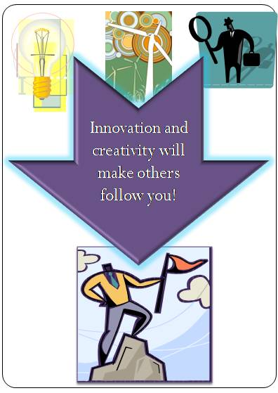

Chapter 10 – Conclusion

There are four golden rules to ride through:

- Constantly update yourself of transformations in outlook
- Do not resist change, else you will be left behind
- Continually keep improving methodologies to keep pace with the market
- Invest in innovation if you wish to be a market leader

Always bear in mind the following while coping with change:
- Do not procrastinate. At the same time avoid panic.
- Perform a risk analysis between changing and maintaining status quo.
- Perform a SWOT analysis (Strength, Weakness, Opportunities, Threats).
- Develop a clear strategy with mitigation plans.
- Develop flexibility with respect to business models.
- Assess financial impact due to change (Cost benefits analysis).
- Develop a system for recording your experiences and lessons learnt.

Here are a few words about dealing with economic recession. It is challenging for the survival of businesses of all sizes. It is especially damaging to small and medium size businesses. It puts pressure on revenues, profits, credit availability and labor. However, the right business strategy can help a business to survive these turbulent times.

First, businesses should make sure they have the true facts about the environment. There are many rumors, innuendos, falsehoods and opinions out there. You need to know the real facts in order to make the appropriate changes to your strategy.

Next, you should apply the business planning techniques for managing uncertainty. Use these techniques for adjusting your marketing strategy, customer strategy, staffing strategy, pricing strategy, competitive strategy and of course, your financial strategy.

There are certain fundamental changes which have to take place in our system to eradicate the problem of a financial crisis. There has to be a shift in the focus as to what has to be changed.

A crisis arises when one or more of the following occurs:
• Desire becomes greed,
• Confidence becomes arrogance,
• Knowledge stagnates,
• Paradigms become stubborn and inflexible,
• Passion gives way for obsession,
• Selfishness leads to micro management,
• Competitiveness becomes aggression.
These things have to change.
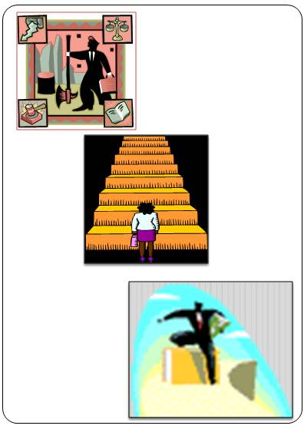

Stick to Perseverance. "Nobody trips over mountains. It is the small pebble that causes you to stumble. Pass all the pebbles in your path and you will find you would have crossed the mountain." Unfortunately we do not know the source of the saying. However, it must surely be someone who had learned the power of perseverance.

Let us keep our minds open for various possibilities.

And let us help build healthier organizations and in turn healthier nations!
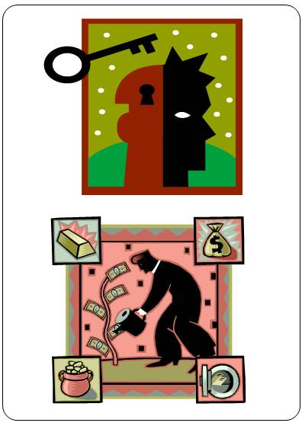

Other titles by the same authors

- Practicing the Scientific Art of Management

- Managing beyond Numbers – Assessing Human Resources Management Strengths

- Corporate Governance manual- Generic

©Lekrish Consultants Pvt.Ltd.
www.lekrish.com

