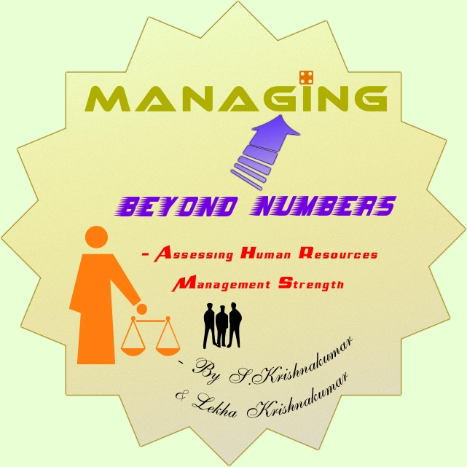

©2008 Lekrish Consultants Pvt. Ltd. retains all copyright and other intellectual property rights for the contents of this book. Unauthorized copying, public performance and broadcasting of this content are prohibited and punishable under law.

About the Book

Purpose

This handbook tries to walk the readers through one of the critical aspects of business management which has innumerable nuances- Impact of Human Resource Capital. Further, it attempts to appraise management teams, regarding problems generally overlooked by organizations due to departmentalization and inflexible job descriptions. The program tries to bring out the dynamics of management amongst the five critical aspects of human resource capital viz., Knowledge, Skill, Competence, Incentives and Belongingness.

Approach

The book highlights certain standard practices which includes over quantification of performance evaluations that are prevalent within many organizations and their impact on the overall performance. During the course of the book remedial measure to prevent/mitigate the problems are also discussed.

About the authors
S.Krishnakumar is an Associate member of the Institute of Chartered Accountants of India which is the premier institution governing the profession of accountancy in India. His total industry experience spans over 15 years which includes extensive financial and management audit experience. He has served as finance controller and business support manager with leading Fortune 500 companies for over 9 years; He has good insights and understanding of international taxation, business development initiatives, strategic planning and human resource management.
Lekha Krishnakumar is a Fellow member of the Institute of Chartered Accountants of India. Her total industry experience spans over 15 years which includes, over 11 years of experience in financial and management audits, company formation, statutory compliance and taxation. She has served as Commercial manager in MNCs responsible for financial planning, project control and customer interface. She has an excellent academic record with state level accolades in economics and accounts, and merit in the foundation course of Institute of Chartered Accountants of India; currently, she has conducted workshops on accounting and management word-wide and gives regular presentations at the Southern India Regional council of the ICAI.

Contents
About the Book 3
About the authors 4
Chapter 1 - Introduction 6
Chapter 2 – Team Building 11
Chapter 3 – Hire right people 14
Chapter 4 - Nurture leadership qualities 27
Chapter 5 - Structure your Organization well 29
Chapter 6 – Map-Competence; Build-Capacity 35
Chapter 7 – Evaluate Performance; Institute Incentive schemes 40
Chapter 8 – Create a sense of belongingness 45
Chapter 9 – Conclusion 49
Other titles by the same authors 52

Chapter 1 - Introduction

George Bernard Shaw once said that “If you have an idea and I have an idea and we exchange these ideas, then each of us will have two ideas.” Here, we are going to present an idea. It probably will increase your idea count by one additional number.
But, before we proceed with the actual topic, we will have to understand about paradigms. What are paradigms? Many of us know the answer already. The understanding that we carry today are paradigms accumulated over the years due to experiences. We will try to answer some questions relating to the topic to see what kind of paradigms we currently carry..
- What is the role we envisage for a traditional auditor?
- If you are a Finance Controller, how would you perform qualitative analysis?
- What could be finance professional’s role towards Human Resources function in an organization?
- Do you think it is important to appraise qualitative aspect of resources including human resources?
Your answers to these questions will reflect the paradigms you have developed over the years.

It has been observed that:
- All of us have paradigms that resist us to appreciate and acknowledge a different perspective.
- Paradigms might take a rigid form with progression of age. Why? Because of ego factor- “I have been doing this for ages now; don’t I know for sure?”
- Some paradigms are due to the socio-economic factors and others are self created.
Now, we are going to try and change some of the paradigms and see another aspect of the same picture.

The purpose of this book is to appraise management teams, regarding problems generally overlooked by organizations due to departmentalization and inflexible job descriptions.
In many organizations, certain standard paradigms and practices including over quantification of performance are prevalent and they have an impact on the overall performance of the organization. During the course of this study, we will also discuss certain remedial measures to prevent/mitigate the problem.
Is it enough to consider the manpower strength of an organization to see if it is bigger than another organization? When we buy a computer, we see the configuration, quality, performance. When it is important to evaluate these parameters for a computer, how about the person using this tool? Don’t we have to evaluate their suitability, quality, performance, skill and competence?
Human resources are the most complicated of all resources in an organization. Even, Freud has not been able to give complete explanation of human behavior! Nobody can say for certain how any person will behave in any particular situation. Also, individual behavior is different from group behavior. So, can, we as managers and finance controllers, ignore this important aspect and restrict our work to just numbers?
Well, understanding various types of human personalities and their cultures would help in the long run in understanding your employees and clients- that discussion is beyond the scope of this book. Here, we are only going to understand the importance of taking into consideration the Human aspect in an organization with respect to their organizational behavior. Human resources are hired on the basis of Knowledge, Skill, Competence and they are committed to an organization based on incentives and belongingness.
Let us take a small example and see how an employee matters. Let us say an employee decides to quit an organization. He stops working for the organization, the moment he decides to quit and starts searching for the job. It may take a couple of months for him to get another job- we have lot of portals today. He will then put in his papers. And we all know, nobody works during notice pay! So, a month of productivity lost there. The company tries to find a replacement for the guy. Let’s say it takes a month. So, another month of productivity gets lost. The new employee joins and starts adjusting to the new atmosphere. He has to be trained to bring the situation back to old productivity levels. That will take at least three months. So, how many man-months lost? Totally, seven man months!
What is the primary job of any manager? To ensure that interests of the company and all its stakeholders are taken care of. How can that objective be achieved without assessing the quality of one most important resource – Employees?
Any organization is because of the people they have. Today, Bill Gates has retired from Microsoft. If he has built a strong team who are committed to values, ethics and quality of output, the organization will go farther. Sometimes, we have felt that in a school when a principal is replaced by another, the quality of service and attitude of teachers undergo a change.
Now, are we fully convinced that we should go beyond what figures say and try and understand what they really convey?

Chapter 2 – Team Building

Team building is of paramount importance in a business.
Effective solutions are provided by talented, skillful and proactive people who can strike the right balance among key business values viz,
• Innovation: Being innovative is the key to being a market leader. Following what others are doing may not be useful or applicable. A creative team makes an impact.
• Promptness: Promptness is a quality which is desirable in every member of a team. Commitment and delivery on time are values which go a long way.
• Quality: Quality of people, processes, output and input are very important for an organization. If members are not chosen properly, it may spell disaster for the whole team. Everybody should contribute well and equally for the success of the team.
• Effectiveness: Effectiveness in performance comes through good communication, planning and coordination among team members. An effective team can do wonders for an organization.
• Goodwill: To build goodwill, right kind of values need to be instilled. It takes years to build goodwill. But, a bad team can spoil it in a jiffy!
• Relationship: Relationship among members internally and externally is very essential. Show stopper qualities like personal prejudices, ego, jealousy, unjustified anger can kill any team effort.
• Satisfaction: Achieving satisfaction is the most difficult thing in life. Why would it not be in an organization? Setting a goal and being satisfied with its achievement is the key to happiness. A satisfied team can build a satisfied organization.

How do we build the right kind of team? By:

- Hiring right people
- Nurturing leadership qualities
- Structure
- Competence Mapping and Capacity Building
- Performance Evaluation and Incentives
- Belongingness
Let us elaborate these aspects one by one and see how we can build the right kind of team.



Chapter 3 – Hire right people

How do we hire the right people for the organization?
To understand this, the first step is to know the job hiring process.

- The first step in the job hiring process is Job Description. Define what needs to be done. For example, in accounts department, you may need an accountant, a cashier, a supervisor, a financial analyst and a finance controller. The scope of work is to be drawn to understand who needs to be recruited.
- Once scope of work is drawn, the second step is Skill Requirement analysis. What do we expect in a candidate? We know, this needs to be done, but what kind of person will be able to do it? What should be the person’s educational qualification, experience level, maturity level, communication skills, adaptability to a place and organization etc. This kind of analysis and mapping is called skill requirement analysis.
- Now we know what is to be done and what kind of person would be required. Now is the time for Costing. How much would a person with the desirable skill set cost the organization? What would be normal market value of the person? What can the organization afford to pay for that particular job? Another important question to be asked here is – what will be the revenue potential – would the costs match revenue generation? Keeping all the answers to these questions in mind an appropriate salary range would be decided for the position.
- When do we need to recruit? Drawing up a Timeline is very important. The recruitment process itself takes time. After having made the decision to recruit, it important to know the time by which the candidate will be ready to start performing. Timeline for not only recruitment process, but induction and training process has also to be considered. Productivity starts only after a person is fuly training and inducted properly into an organization culture.
- The next step in the recruitment process is Profile match. There are various ways of drawing profiles of candidates. It could be through recruitment agencies, online portals, newspaper advertisements, classified columns, reference etc. Profiles can be evaluated and matching candidates shortlisted for review.
- Candidate review is done of all the short-listed candidates by conducting tests/ interviews/ discussions etc. What to look for in a candidate is discussed in detail in the next section.
- Once a candidate it selected after careful evaluation and scrutiny, Employee induction takes place. An employee needs to be trained in the processes, values and organizational culture first, before he starts performing. This process of acquainting an employee with the organizational procedures, rules, policies, values and systems is called employee induction.

Let us now discuss in detail the answer to the question: What should I look for in a candidate?
- Knowledge: This is the first test for any candidate. A person should be knowledgeable with respect to subject, industry, working atmosphere.
- Skill: Depending on the job requirement the skill of a person has to be analyzed. Communication skills, interpersonal skills, linguistic skills, managerial skills, listening skills, written skills, presentation skills, are some of the important aspects to be evaluated.
- Competence: Next is competence of the person. A person may possess required knowledge and skills, but he may not be competent enough to handle a position. He or she may lack the requisite experience, maturity or vision.
- Cost: Fitting the bill is a very important criterion. A candidate may be very good, but if his or her asking compensation is exorbitantly high and the cost does not justify revenues, it may not be possible to recruit that person. It is difficult to carry white elephants in an organization. It is also important to ensure that the existing employees are not offended due to the very high value paid for a new recruit with similar or lesser skills, experience and capabilities.
- Attitude: To highlight the importance of attitude, we present here a very nice presentation which we received from a friend on the mail network. We are not aware of the source of this. This is a very interesting thought, which will help us understand the value of attitude in life.


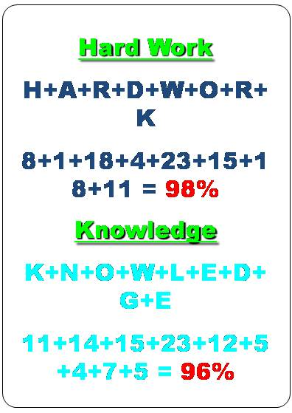
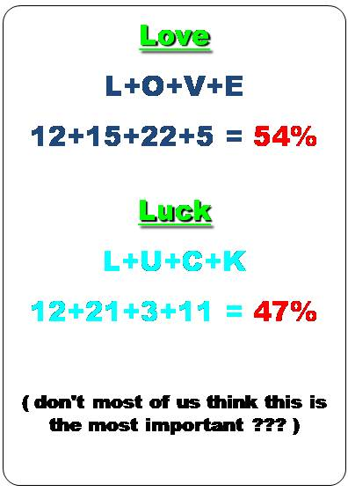
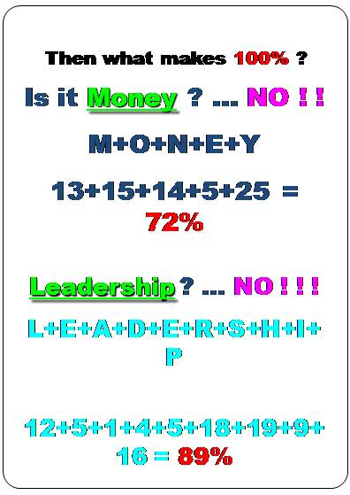
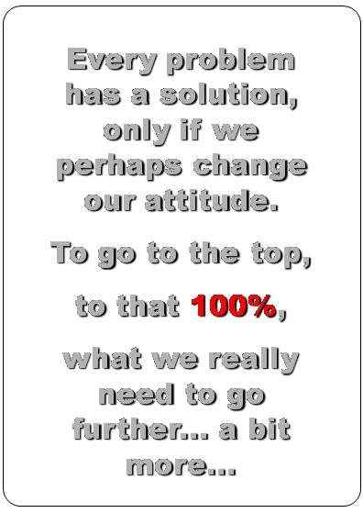
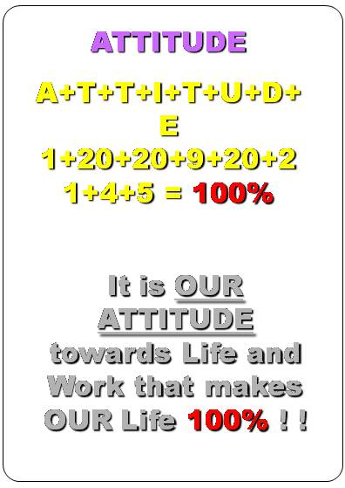


- Adaptability: Having understood the importance of attitude, let us examine adaptability. Desirable candidate should be adaptable to the organization culture, working environment, present staff structure and any change that may take place from time to time in the internal as well as external environment. He or she has to adopt flexibility, creativity and congeniality in order to be able to adaptable.
- Values: Last but not the least is the values. A person who lacks in basic values of honesty, sincerity, truthfulness, courteousness, integrity, propriety and sense of balance cannot be recruited by any organization.

Chapter 4 - Nurture leadership qualities

Leaders are more effective than managers. Managers delegate responsibility and retain authority??!! Leaders lead by example. Managers should be natural leaders for the team to become very effective. It is said managers are made and leaders are born. It may be true, but by nurturing certain values and qualities a manager can be made into a leader.
Leadership is required not only at the top level but at level of the organization. Right from a factory foreman to a managing director, every manager should be a leader. Indecision, escapism, shirking responsibility, absolute confusion in thinking are certain qualities which need to be discouraged to be able to make a good leader out of a manager.
Today, much is being talked about developing leadership. But do we understand the difference between a Leader and a Manager?

Let us say, a problem has arisen in an organization. A Manager would ask why something went wrong and who did it? Pin-pointing responsibility to a person is his first concern rather than solving the problem.
Whereas, a good Leader would ask what went wrong, how it happened and how it can be solved. Crisis management and problem solving is his first concern than holding any person responsible. Later, when the problem has been managed properly, he will search for the causes and reasons and try and ensure that it does not recur. This may involve counseling the person responsible for the act, changing the job portfolio or adopting different methods of work. Blame game is a useless exercise and has no positive effect on the organization as a whole.


Chapter 5 - Structure your Organization well

Prepare a clear organization chart and define roles and responsibilities of each person in the organization.
Once a clear structure is established, the same has to be communicated to each and every employee. Communicate the mission and vision and the role the team member is expected to perform and why? He should understand where he stands, what is expected of him, and why he has to perform a particular role.
For example, if a team is formed in an organization to execute a software development project, every member of the team has to be assigned a clear role. Team leader has to be identified. Every member should know what he is going to do, when he is going to do it, who is he going to report to for his work and what is the measure of his contribution going to be in the whole project. Every person has a role to perform. Starting from a programmer, everyone in the team should know repercussions of what he is doing. A small error he makes due to his carelessness or callousness may have far reaching impact on the whole project.
Clear performance parameters have to be established to avoid discords. Taking the same example as said earlier, a programmer has to know the length of the project, timeline within which the coding has to be completed, quality testing timeline and maintenance phase. He should also be told about the location of the project team – off shore or on-site and if off-site, if he will be expected to take any travels to the customer location during any part of his project development. This also highlights the capabilities of the manager to prepare plans for these deadlines and communicate to every team member.
Effectively communicating objective decisions and critical feedback is very essential. Let us take the same project as example. Let us say the project has been priced taking into consideration travel for two people once during the tenure of the project. One of the persons travelling would be the system analyst and another would be one of the programmers. Say, there are five programmers in the team. The team should take an objective decision of sending the programmer who will be best suited to handle real time situations in front of the client. It should not be based on any subjective criteria like one programmer has not travelled to the US at all and would like to go around the world.
Similarly, if one team member is not performing well, it should be communicated to him through proper channels in the right perspective. Accusing somebody of slack work is not a good approach. A person may lose the incentive to work properly if given over critical remarks where it is unwarranted. Why a critical feedback is given should be understood before giving it. The importance of the feedback and the motive behind a feedback is important.
It is very important to establish effective communication channels and whistle blower policy.
What is a Whistle Blower Policy?
Many of us understand this terminology. But some of us would require an explanation. In an organization or let us say in a team, any team member, either directly or through a written communication, can make a complaint to the highest management along with necessary evidence to highlight any of the following acts of misconduct:
- Violation of any law or regulations,
- Corruption, theft, fraud, coercion and willful commission,
- Conflict of interest,
- Mismanagement,
- Gross wastage or misappropriation of company funds/assets,
- Manipulation of Company data/records,
- Leaking confidential or proprietary information,
- Unauthorized use of Company’s resources
- Activities violating Company policies.
- A substantial and specific danger to public safety.
- Misuse of authority.
- An act of discrimination or sexual harassment.
- Any other act that is bereft of general oral standards affecting the interest of the company.


The purpose of this policy is to:
- Encourage employees at all levels to report to the highest management without any fear of harassment.
- Ensure transparency within the enterprise and thereby build trust.
How these complaints are handled is very critical. They should not be handled like conflict resolution. Confidentiality is the key. Therefore, management should give utmost consideration to this factor. An independent investigation would be required to assess the validity of each and every complaint.

Chapter 6 – Map-Competence; Build-Capacity

Competence mapping means evaluating the existing manpower with respect to their skills, knowledge, and competence viz-a-viz the roles and responsibilities they perform. Just ensuring right person is doing the right job. Suppose a person is suited only for a desk job, if you ask her to go around places meeting people, then it is a mismatch of roles. The person may not be doing justice to her role. Similarly, if you ask a person who has done accounting and finalization for twenty years, to take up financial analysis and business case preparations, he may not have the aptitude to do it. If a person is just not cut out to do a particular job, he should not be asked to do it. Then you will be wasting your resource and the person will be wasting his time without any output.
It is very important to analyze the capability of each individual to take up a particular assignment. Many times, some people in over exuberance to please the management may agree to take-up some assignments, but they may not have the competence to manage it. Also, because of rigid HR policies, some highly creative people with good leadership qualities may be performing some clerical work. It would undermine the capability of that kind of resource.
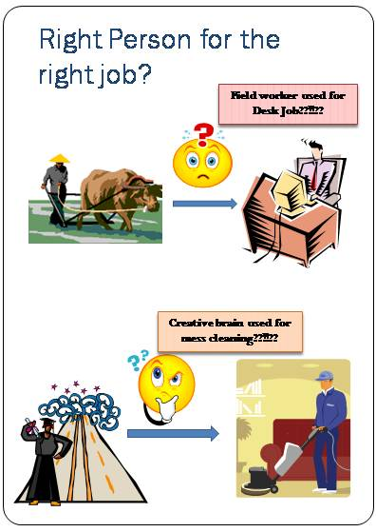
Capacity is a very critical ingredient for sustenance in a dynamic environment, continual improvement and overall development of the organization. It is in fact more important than finance.
A single instance of weakness of capacity within a multi stakeholder organization would sabotage the implementation of the vision and mission.
UNDP has defined “Capacity” as “the ability of individuals, institutions and societies to perform functions, solve problems, and set and achieve objectives in a sustainable manner”.
Capacity building would therefore mean developing the ability of humans and institutions for effective achievement of set objectives and planning to meet higher goals.
Capacity building within an organization is one of the most challenging functions.
Adequate and appropriate human resources with satisfactory remuneration packages and incentive plans are the starting points for achieving the standards of effective governance. It should be backed by sound policies practiced in a transparent manner with adequate financial budgets and reliable statistics and strategies.
Therefore, Capacity building would have the following key ingredients:
- Identify strategies for building capacity through a professional and organizational approach, based on industry standards and sound research.
- Identify the skills and qualifications required for each job and map the current staff capabilities.
- Analyze the gaps between the desired levels and current capabilities.
In partnership with various support organizations and consultants institute human resource development plans and programs to bridge the existing gaps.
Again, in the present scenario change is the order of the day. In order to survive in this dynamic world it is very essential to bring about a paradigm shift and manage change effectively. Capacity building is one of the key functions to manage change.


Chapter 7 – Evaluate Performance; Institute Incentive schemes

Performance evaluation review processes: Performance of each employee has to be evaluated periodically. A combination of top-down, bottom-up and peer review measures can be adopted for an objective evaluation of any individual. Scientific methodologies and score card systems can be established. But, the human element cannot be done away with altogether. For any review process to be successful, it should be both scientific and humane.
Banks have installed a “KYC-Know Your Customer” concept. But, how many of them follow it objectively? They have scorecard systems for sanctioning loans etc., which may give mis-leading results many times.
Let us take an example. We came across a person who had a net worth of about rupees forty lakhs. He was in need of some liquid funds for running his business and approached a private bank for overdraft. The bank asked multiple questions, asked for property papers and did some verification in various places and came up with the answer that they cannot even sanction rupees one lakh as overdraft limit. That’s what their score card said! But, his own employee who was paid rupees four thousand a month by him got a personal loan of rupees one lakh from the same bank. Pay-slip was proof enough to sanction the loan!
Similarly, while establishing score card system for employee evaluation, we have to ensure that it is not too technical and form does not take precedence over matter. A person’s individual capability may not be measured correctly using only technical measures.
Let us take another example. In a company there are two departments A & B. There are two financial guys – they are called “commercials” in some organizations. They report to the business manager. Their annual bonus and increment are to a great extent dependent on the department’s performance.
Department A sells fast moving commodities. It has a robust sales team. They make huge profits. The “commercial” is an average person. He does not have to do much. The systems are working properly.
Department B is slightly slack. The sales team is not able to generate good business leads. The “commercial” is a shrewd person. He raises alarm at right time. But, the business manager is very defensive of his team and refuses to take his advice seriously. Eventually because of the “commercial’s” constant and untiring efforts, they are able to salvage the department from going into the red.
But, the score card says, Department A “commercial” should get a hefty bonus and good increment, whereas Department B “commercial”, cannot get a bonus or an increment.
Is the score card revealing the right picture? Who deserves increment and bonus more?
Establishing transparent and objective incentive plans: Money is the most important incentive. But, some people may not be satisfied just with money. They require good designation, right kind of roles and good amount of power – some kind or the other.
Sometimes, office atmosphere may also be a good incentive. Nice swanky workstations act as incentives to work for an organization. Proper utilization of one’s capability is important. Under utilization may also sometimes lead to boredom and under performance, for the person lacks the enthusiasm, the zing to perform.
Let us take an example. In a school there was a teacher- a mathematics teacher. He was teaching for middle sections -6th/7th classes. He was rated as a poor teacher. He didn’t go to classes properly, didn’t attend to students’ queries. Later on after a few years, he got a promotion and was transferred to another branch.
A student, who had studied in the previous branch in a lower class, also switched schools when he reached a higher class and happened to study in the same class where this mathematics teacher was teaching. He was initially little upset as the feedback received earlier wasn’t very good. But, when the classes began, he was so surprised. The mathematics teacher happened to be the best teacher he had ever had in any class before. He was a genius and could solve any complicated sum. And when mathematics Olympiad results were announced, this student was the only one to get any medal from that school. He had to thank his mathematics teacher for that. Later, he found out that the mathematics teacher was very unhappy with the school management who refused to give him promotion and gave promotion to less capable teachers who were also his juniors.
This point once again highlights the inability of a manager (probably a principal in this case) to assess the capability of an individual properly as he confines himself to certain defined parameters when deciding on giving promotion.
A good leader is one who judges a person’s capability and utilizes him to the best of his abilities for the betterment of the organization. And a good management is one which can show flexibility in supporting the leader.
There are so many ways of giving incentives to employees. Suppose, if a crèche is established, it would be beneficial to many women employees. Flexible work timings, good leave policies; flexible locations are examples of some more incentives. More and more organizations are coming up with innovative ideas to give incentives to their employees.


Chapter 8 – Create a sense of belongingness

What is belongingness?

Everybody in this world likes to draw power from one or the other source - political power, power of position in corporate, name and fame in media etc. These are known and established sources of big power. But, there are also other sources. An autocratic father likes to dictate terms in the family. A social worker likes to draw power by thinking that they are better human beings than others as they care about the deprived which many people do not do. Then women wield a different kind of power over husbands and sons. Mother-in-law – daughter-in-law tousle is an age-old story.
There is also a sort of power to be drawn from a sense of belongingness to an institute – educational or charitable or an organization. If a student is studying in a reputed college, he takes pride in it. Similarly, one takes pride in belonging to a Temple or some Organization. Others take pride in working for some big corporate, like working for Infosys, IBM, Microsoft etc.
How have these organizations been able to create this reputation and why would people like to be employed in them? It need not necessarily be the size. It is the overall culture of an organization. A person should be happy to work for a company. It need not be a very well known company. But, there are certain aspects and values in an organization which makes people loyal to the organization. As we saw earlier, attrition causes a lot of loss in terms of money and efforts. Therefore, it is of great importance to retain the employees. To retain more and more employees, money alone may not be the trigger. Cultivating a good Organizational culture would be the key to retaining good talent.
Apart from recognizing and rewarding talented people, there are some other aspects which need to be adopted for a better organizational culture.
Show flexibility to amend mistakes as opposed to defending them. The management should not be rigid with respect to its decisions. For example, in a company, during annual assessment an executive in Mumbai region is given promotion and another executive with better qualification, experience, capability and role is not given a promotion, the other executive may feel cheated by the organization. These things are pretty common in corporate as we all know. But, this could have happened due to various reasons. We are not going to delve into nepotism aspects here. But, if this fiasco happens due to neglect or oversight on the part of the management, then instead of defending the decision, they ought to own it up and make a correction immediately, so that the person does not leave the organization.
Evolve a policy of giving credit when voluntary disclosures of lessons learnt from mistakes are communicated. If an employee makes a mistake and discloses it voluntarily, instead of punishing the person, he or she should be given credit for owning it up and should be given a chance to amend the wrong done.
Develop a feeling of pride within the individual to be a part of the team. How can you develop a feeling of pride within an individual? If a person is capable, he should be recognized, given good challenges and encouraged to take more responsibilities in the team and should also be rewarded for the extra efforts. There are other things which could be done like taking the team out for lunch or dinner once a while, meeting informally outside the office set-up with family and friends, treating with gifts at the achievement of a milestone, indulging in group activities like sports etc. Some more benefits can be extended like subsidized services, extension counters, ATMS within office premises etc.
If a person gets a sense of belongingness, his commitment, and quality of output increases. He gets motivation to perform better and is more inclined to stay on in an organization for a longer period of time.


Chapter 9 – Conclusion

Now, you will ask, fine! Quality is important, Human resources cannot be ignored, but how can I assess quality?
When an organization is not performing well, what do we see?
Top-line is not good, costs are high, and bottom-line has to be increased somehow. So, we put pressure on marketing department to bring more business, administration department to reduce overheads and probably consider retrenchment to reduce manpower cost.
These remedial measures may work. But, key problem may be somewhere else. Here is where there has to be a paradigm shift. The problem could be because, right kind of people are not hired or people are not aware of their exact roles or competence mapping has not been done properly or people are not getting incentives or there is too much attrition as there is no sense of belongingness.
Role of a manager is also controllership. Control cannot be limited to numbers; it also requires analysis of the whole organization.
What has been done above is reaction to a symptom. Sometimes, there may not be a symptom. Things may look healthy on paper but that may not be the actual case. A cricket team can win a match by fluke or luck of the day. That doesn’t mean the team is extremely good. There may so many problems with the team.
Similarly, managers need to be pro-active. We have to constantly keep evaluating things. If we are aware of problems that are generally faced in an organization, we can probably investigate and pin-point the exact issue to take corrective action. This could be more beneficial than reducing stationery cost! A head ache need not mean migraine or sinus or poor eyesight. There could be a deep rooted problem which is showing itself as a head ache.
A proper diagnosis is required in that case.
Managers have the responsibility of constantly monitoring and evaluating if the organization is going towards ill-health. A good diagnosis is half treatment! Therefore, we have to look beyond numbers, induct ourselves into the role of a good doctor who could pin-point the correct problem area.
Only then can any remedial action be taken. After the diagnosis is made a good recommendation can be given for corrective action.
As we say healthy minds and bodies constitute healthy human beings, similarly, healthy organizations constitute healthy economic world! Let us open our minds. Let us build a healthy economic world!


Other titles by the same authors

- Practicing the Scientific Art of Management

- Adapting to the environment - Challenges in managing change

- Guidance for creating Corporate Governance manual

©Lekrish Consultants Pvt.Ltd.
www.lekrish.com

